Lab 10: Simulate CLA, CMA, SPA, SNA Operation

Learning Objectives:

* Understand the Clear Accumulator (CLS) operation.
* Define and implement Complement Accumulator (CMA) in CPU Sim.
* Observe how Skip if Positive (SPA) and Skip if Negative (SNA) affect instruction flow.
* Apply CLA, CMA, SPA, and SNA in conditional execution and control flow.

Essential Tools in Our Lab:

* + **Computer System:** The main machine
  + **CPU Sim**: CPU Sim is a tool used for simulating simple CPU architectures, helping students understand processor design, instruction execution, and debugging.

Basic Machine Instructions

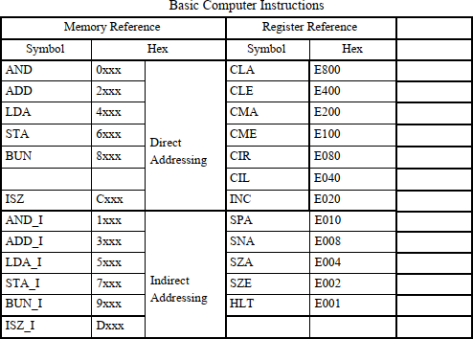

Step-by-Step Execution:

Step 1: Navigate to the Microinstructions Section

* **Open your simulator/tool and access the Microinstructions Section.**

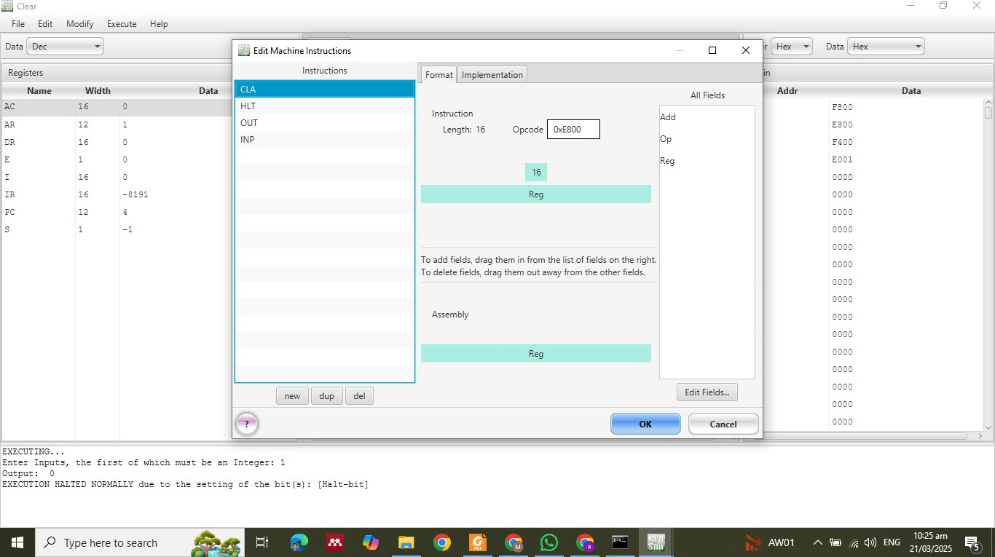

Step 2: Define CLA Microinstruction



Step 2: Define CMA Microinstruction

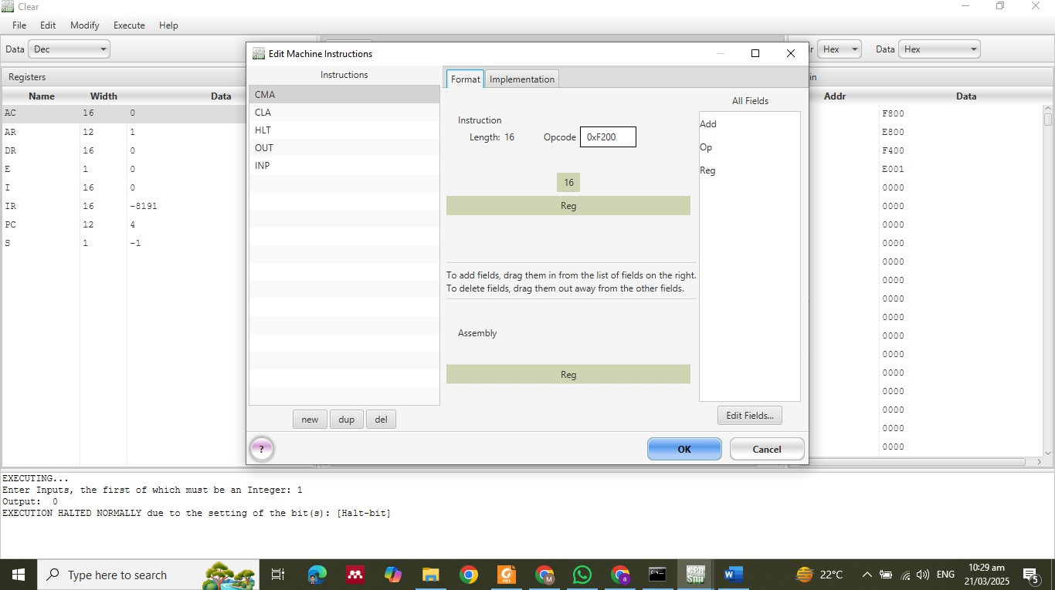

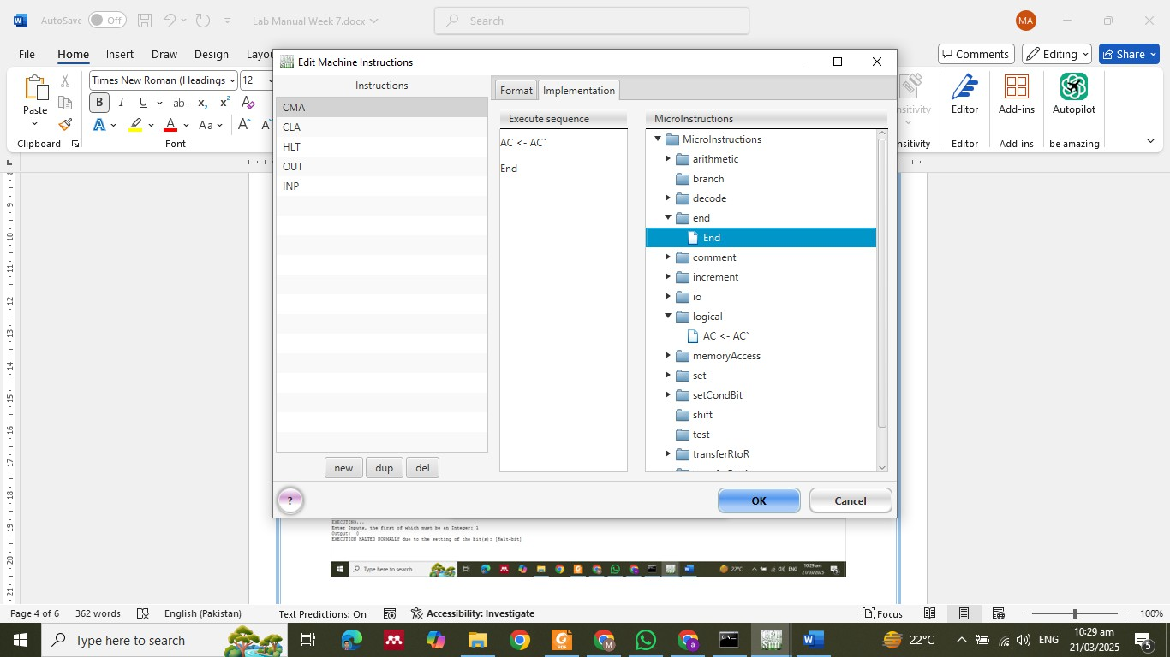

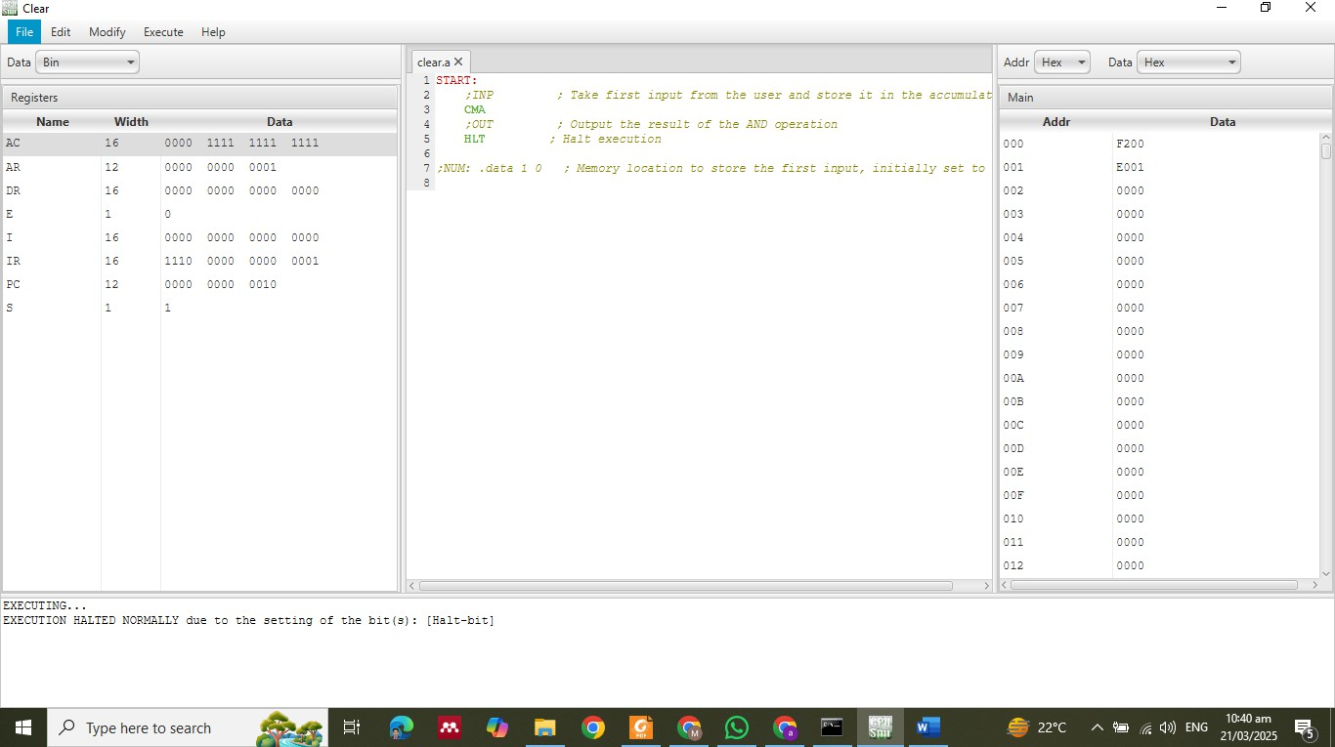

Working Mechanism of SPA

1. **Checks the sign bit of the accumulator:**
   * **If the most significant bit (MSB) is 0, the value is positive, and the next instruction is skipped.**
   * **If the MSB is 1, the value is negative, and execution continues without skipping.**

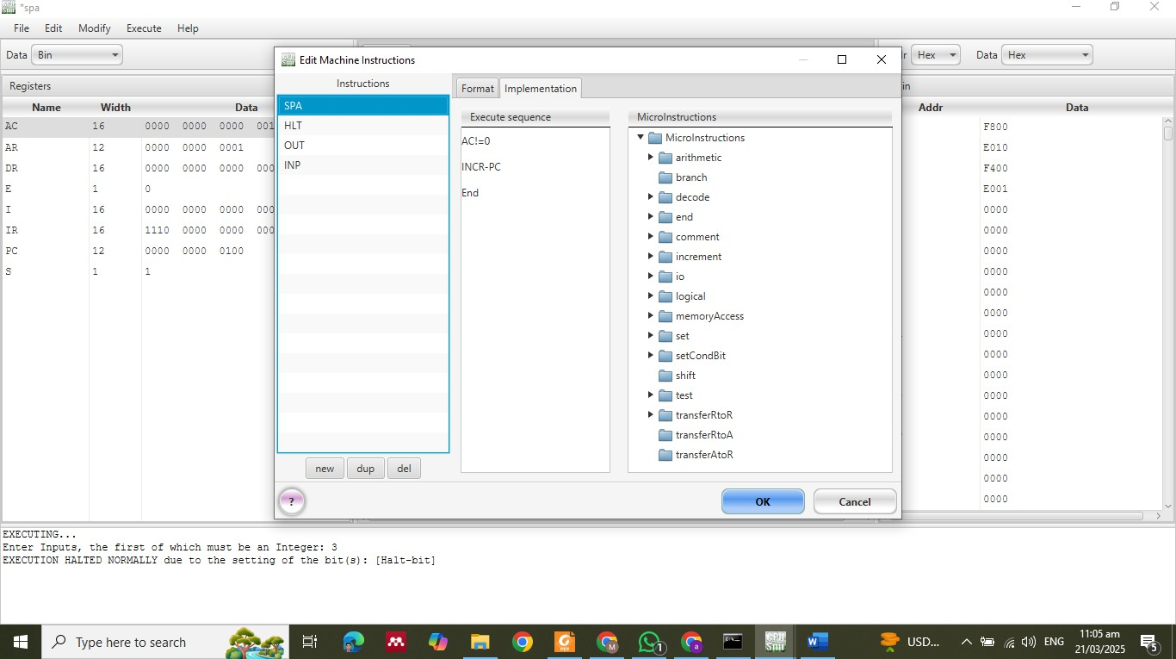

Lab Tasks

Task Requirements:

1. **Verify that CLA sets the accumulator (AC) to zero.**
2. **Verify that CMA inverts all bits in the AC.**
3. **Increment AC by 3.**
4. **Skip next instruction only if AC is positive.**
5. **Skip next instruction only if AC is negative.**